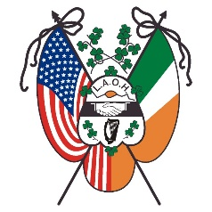
Ladies Ancient Order of Hibernians, Inc.
New York State Board
State Board Meeting Guidelines

Pursuant to Article VIII Section 3 of the New York State By-Laws
Last Revised in Syracuse NY 2021

- State Board Meeting will be conducted with dignity, protocol and decorum of a State Convention modified to the extent that time requires.
- The County President or her alternate, all Past County Presidents with no alternate, and all Division Presidents, or her alternate shall be a delegate at State Board meetings with a voice and vote but at no expense to the State Board. Designation of alternates should be in accordance to descending order of office.
- Roll Call by the State Secretary shall be made at the beginning of each State Board Meeting.
- No State Officer can represent her state office and county office at the same time. She either represents her State Office and has her expenses paid by the State Board or represents her County with expenses paid by her County Board. She cannot collect from the two Boards.
- No County President or her duly elected alternate can submit any subject for discussion at a State Board Meeting that has not been discussed and voted upon at her County Board Meeting.
- Any member of the Order in New York State in good standing may attend a State Board Meeting but will have no voice or vote.

All State Officer and Appointee Reports will be available on-line, April 26, 2024, (seven days before the May 4th State Board Meeting), for the County Presidents to print in preparation for the meeting. No written reports will be distributed at the meeting. The reports will be located on the State website www.laohnys.com County President resource page.

