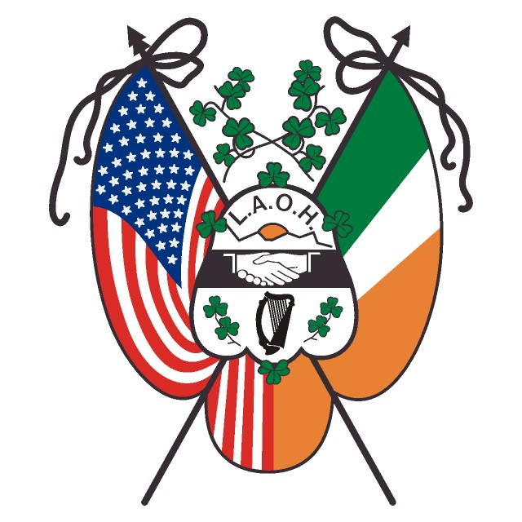
LADIES ANCIENT ORDER OF HIBERNIANS, INC.
NEW YORK STATE BOARD

August 2019
2019-2021
New York State Board
Chaplain
Deacon Charles Z. Wojton
cwojton1@nycap.rr.com

President
Mary Beth Durkee
mbdurk7@gmail.com

Vice President
Agnes O’Leary
laohaggie@gmail.com

Secretary
Regina Begley
laohregina@optonline.net

Treasurer
Therese Meyer
tmmeyer4@gmail.com

Irish Historian
JoAnn Gundersen
jgunde2000@aol.com

Missions & Charities
Catherine Doherty
cathieedoherty@hotmail.com

Catholic Action
Teresa Kearns
irishsmiles17@verizon.net

Past President & Organizer
Jacqueline Clute
banbha1021@gmail.com

Appointees

Auditor
Christina Parisi
clp110388@hotmail.com

Freedom for All Ireland
Joan Moore
joan55mmoore@msn.com

Fundraising
Mary “Sissy” Durkee
mdurkee1@nycap.rr.com

Immigration & Education
Jeryl Hess
dalunchlady1@aol.com

Information Technology
Kimberly A Clancy
laohnysweb@gmail.com

Public Relations
Mary Hogan
LAOHBklyn@aol.com
Cell Nbr 917-699-9290

Addresses and phone numbers are available on the website
laohnys.com
Members Resource Page

Dear Sisters,

Allow me to introduce myself, I am the newly appointed LAOH NYS Public Relations/Publicity Chair. My name is Mary Hogan from Kings County. I am looking forward to working as the LAOH NYS PR Chair; this was one of the first appointments I had on the LAOH NYS Board; I am proud to have started our state newsletter. A big thank you to our new LAOH NYS President, MaryBeth Durkee for affording me the honor to serve as your LAOH NYS PR Chair.

I am working on getting our email list updated for all the LAOH members in NYS; having correct email addresses for our members is very important since this is the way we will be sending out our LAOH NY state newsletter, St. Brigid’s New York Connection. Our new State Secy. Regina Begley has sent me a list of emails taken from your last yearend membership report; many divisions and county boards have not entered a Public Relations/Publicity Chair, every division and county board should appoint a Public Relations Chair. Your Public Relations/Publicity Chair must have access to email since that is the way all newsletter submissions have to be sent to me for the newsletter.

Duties of County and Division Presidents: Appoint a Public Relations/ Publicity Chair and let me and the rest of the LAOH NYS Board know the name and contact info of your appointee and include this info on your yearend report.

Duties of Public Relations/ Publicity Chairs: Submit worthy articles to the LAOH NYS PR Chair, following chain of command. Publicize your local events in local newspapers, Diocese papers, website, Facebook pages etc. Keep copies of all submissions from your area; this is part of your division’s history and records that you are required to pass on to the next Public Relations/ Publicity Chair. REMEMBER that publicity about our Order and our good works is good for membership.

Submissions for the National Hibernian Digest (National AOH Paper): All submissions from any LAOH NYS Division, County, or NYS Board member must go through the LAOH NYS PR Chair ( LAOHBKLYN@AOL.COM ) The deadline to have an article to me are January 25th, March 25th, May 25th, July 25th, September 25th, November 25th of each year. I have attached a copy of the Hibernian Digest requirements. Our (LAOH) space is very limited so please adhere to the attached requirements.

Submissions to our LAOH St. Brigid’s NY Connection: All articles should be submitted in a windows “WORD” format. Do not send your articles as a Pdf. The only Pdf’s that will be accepted are scanned copies of old documents or photos for your history memorabilia. If you do not have Word please type your article in an email for submission. If your division has a County Board please forward to your County PR Chair. All articles will be submitted via your County PR Chair. Please submit your articles to me, Mary Hogan LAOHBKLYN@AOL.COM.
Deadlines for submissions:

Below is a separate page outlining submission details for the LAOH, St. Brigid’s New York Connection. I am looking forward to hearing from all our Divisions, County and NYS Board members. I will be sending out a convention issue in a few days. If you need any help or have a question please feel free to contact me at LAOHBklyn@AOL.COM home nbr 718 815-7255, cell nbr 917 699-9290.

Yours in Friendship, Unity, and Christian Charity
Mary Hogan
Mary Hogan
New York State Public Relation/Publicity
Ladies Ancient Order of Hibernians, Inc

LADIES ANCIENT ORDER OF HIBERNIANS, INC.
NEW YORK STATE BOARD

LAOH NYS PR Chair
Mary Hogan -- LAOHBklyn@AOL.COM

Submissions to our LAOH St. Brigid’s New York Connection:
All articles should be submitted in a windows “WORD” format. Do not send your articles as a Pdf. The only Pdf’s that will be accepted are scanned copies of old documents or photos for your history memorabilia. If you do not have Word please type your article in an email for submission. If your division has a County Board please forward to your County PR Chair. All articles will be submitted via your County PR Chair. Please submit your articles to me, Mary Hogan LAOHBKLYN@AOL.COM.

Deadlines for submissions: February 28^{th (}please remember to include your St. Brigid events); March 28th; May 28th; September 28th; November 28th. If there are any changes to these dates your PR/Publicity Chair will be notified via email.

Our LAOH NYS newsletter ‘St. Brigid’s New York Connection’ will have several sections:

LAOH NYS Board articles on what is going on in their office or appointment.

Drape the Charter- this is the section we will list our death notices. If one of our members dies please send in an obituary and a photo if you have one. Please include a little personal info, her Hibernian info and any notable events in her life. If there is an address to send a mass card to the family or her division please include it.

County/Division news- every County and division should be submitting an article about what is going on in your area. Please include details, don’t just say we honored someone please say why they are being honored; what is meaning behind the award/honor. Our members do many awesome things so don’t be afraid to tell your sisters in New York State. Include your division/county annual events, charity, Mission work, Project St. Patrick events and history projects.

Photographs- Please send photos (Jpegs) in a separate file, DO NOT paste into a Word document. Photos should be a high quality, same as Digest submissions, over 1mb. Identify all persons in photo. DO NOT send photos of drinking- they will not be published.

Special Events- if your division/county is having a special event, charity, or history project please submit it as a separate detailed article.

LAOH 125th HISTORY- all divisions and counties are asked to submit as a separate article an event in your local history for each issue of the LAOH, St. Brigid’s New York Connection. We want to share our LAOH history so we need every division and county to send a separate article with a noteworthy piece of your history. It doesn’t have to be your whole history all at once, can be a memorable time or event in your division or counties history.

Please email all submissions to LAOH NYS PR Chair, Mary Hogan at LAOHBklyn@AOL.COM
If you have any questions please email me
or call – home nbr 718 815-7255, cell nbr 917 699-9290

