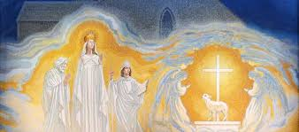
Deacon Charles Z. Wojton
513 Fourth Street
Troy, New York
12180

I am honored to serve the New York State Ladies of the Ancient Order of Hibernians as Chaplain. I would like to thank President Mary Beth Durkee for asking me to serve you as your Chaplain.

I’ve been married to my wife Dolores Wojton for 51 years and we have 2 grown children, Elizabeth Ann and Charles Jr. we are blessed to have 4 grandchildren, Jordan 23, Meghan 21, Charles III 11 and Gianna 9.

I was ordained a Deacon in the Roman Catholic Church on May 20, 2006. I have served at St. Joseph’s Church in South Troy for 7 years and I’m now assigned to St. Antony of Padua Church in Troy. My duties include assisting at Mass, preaching on occasion, offering the Sacrament of Baptism and Marriage when requested and performing funeral and graveside services.

I am retired from First Albany Corporation where I was Vice-President of Computer Operations. My membership in he Ancient Order of Hibernians began in the 1980’s when I joined the AOH James Connolly Division #8 in Troy, N.Y. I have held offices as Treasurer, Secretary, and Chaplain.

As your Chaplain I will offer opening prayers and a brief reflection. I hold you in my daily prayers and ask for yours. Together may we have a wonderful 2 years working in union to achieve our goals of fostering Friendship Unity and Christian Charity.
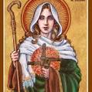

St. Brigid Pray for us

Peace Love Joy
Deacon Chuck

