Ladies Ancient Order of Hibernians, Inc
New York State LAOH Appeals for Aid
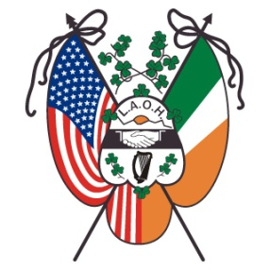
2021 Application for Patricia Doyle Memorial Grant
In a short paragraph (3-5 sentences), state the Mission and Focus of the entity.
________________________________________________________________________________________________________________________________________________________________________________________________________________________________________________________________________________________________________________________________________________________________________________________________________________________________________________________________________________________________________________________
- In a short paragraph (3-5 sentences), describe the entities’ sources of Revenue.
________________________________________________________________________________________________________________________________________________________________________________________________________________________________________________________________________________________________________________________________________________________________________________________________________________________________________________________________________________________________________________________
- In a short paragraph (3-5 sentences) explain how the persons served by the entity will benefit from a One Time Contribution if designated for contributions for the 2019-2021 Term of Office.
________________________________________________________________________________________________________________________________________________________________________________________________________________________________________________________________________________________________________________________________________________________________________________________________________________________________________________________________________________________________________________________

2021 Application for Patricia Doyle Memorial Grant (continued)

- Attach copies of the following documents from the entity being considered:
___________ Constitution/By Laws _______________ Nonprofit Approval

___________ 2019 and 2020 Budget _______________ Marketing Materials

___________ Copy of Licensing Approval _______________ Copy of Accreditation

___________ other documents that support application

Please specify documents provided _________________________________________________
______________________________________________________________________

- Please specify the dollar amount being requested for consideration by the New York Ladies Ancient Order of Hibernians, Inc. $_________________

*Provide any other comments in a short paragraph (3-5 sentences) to support your request for your designated entity for consideration by the 2021 New York State LAOH Convention Delegates. Attach your additional comments to your application.
____________________________________________________________________________________
____________________________________________________________________________________________________________________________________________________________________________________________________________________________________________________________________________________________________________________________________________________________________________________________________________________________________

_____________________________________ ______________________________
Signature of Applying Agent Date

PATRICIA DOYLE GRANT ‘APPLICATION’ MUST BE POST-MARKED BY SATURDAY, APRIL 24, 2021. MAILING ADDRESS IS: CATHIE NORTON-DOHERTY, 15 LAKE SHORE DRIVE, PATCHOGUE, NY 11772. E-MAIL IS: CATHIEEDOHERTY@HOTMAIL.COM TELEPHONE: (631) 905-9388, FOR ANY QUESTIONS.

For NYS Missions & Charities Office Use

_________________________ Date Application Postmarked

_________________________ Date Application Received

Application: ___________ Complete with supporting documents

___________ Further information requested Date: _____________

